* To load data into mysql workbench using csv files in two ways

1. **The file mode making it on to load the data from csv**

SET GLOBAL local_infile = 1;

**To check if the access for local file is set to on or not**

SHOW GLOBAL VARIABLES LIKE 'local_infile';

**To load a file**

LOAD DATA LOCAL INFILE

'/Users/mohammedshehbazdamkar/Downloads/WalmartSalesData.csv.csv'

INTO TABLE sales

**To distinguish between columns**

FIELDS TERMINATED BY ','

*means that we are using a comma-separated file.*

**To enclose**

ENCLOSED BY '"'

Note: *means that values with a comma inside should be wrapped in the double quotation marks. This is to prevent separation*

**Start of a new line**

LINES TERMINATED BY '\n'

**Rows containing headers**

IGNORE 1 ROWS;

MySQL Workbench is a comprehensive tool for modeling, generating and managing databases. The [Community Edition](https://dev.mysql.com/downloads/workbench/) is a free version which you can download from the Oracle website.

This method demonstrates two ways to use the MySQL Workbench tool for data import. If you want to use a graphical user interface, you´d first need to remotely connect to the MySQL database.

**Step 1. Install MySQL Workbench and connect to the database**

When you open Workbench, click on the **Database** -> **Manage connection** and set up access to the MySQL database.

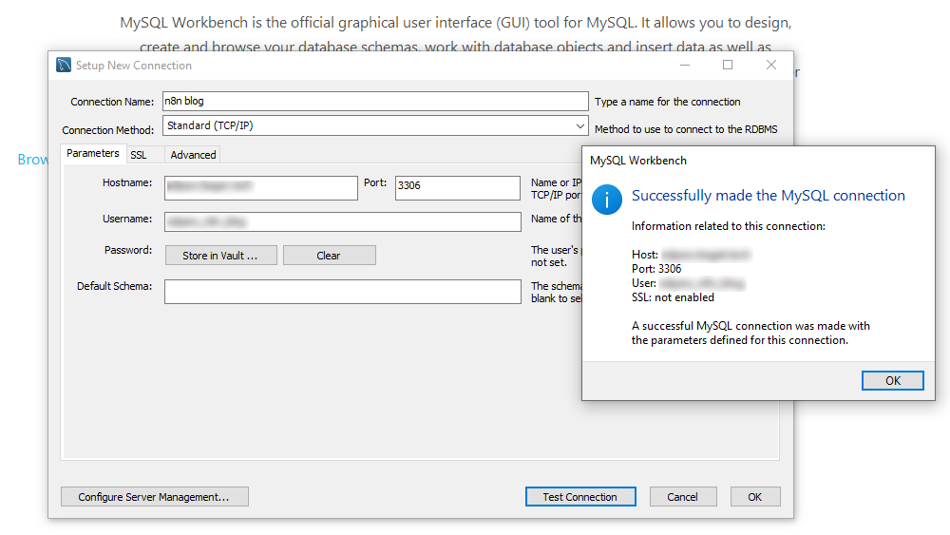Connect to remote MySQL database in Workbench

In this example, we're going to make a remote database connection.

💡

Please check in advance that your database accepts remote connections. Some hosting providers restrict remote access for security reasons.

Enter the **Connection name** of your choice, then the **Hostname**which is either an IP address or a server name. In most cases the **Port** should have a default value (3306). Then fill in the **Username** and **Password** and test the connection. If everything runs well, you will see a confirmation.

💡

Finally, click on the **Advanced** tab and provide an extra line in the **Others** text input: **OPT_LOCAL_INFILE=1.**This is important for uploading data from a local CSV file.

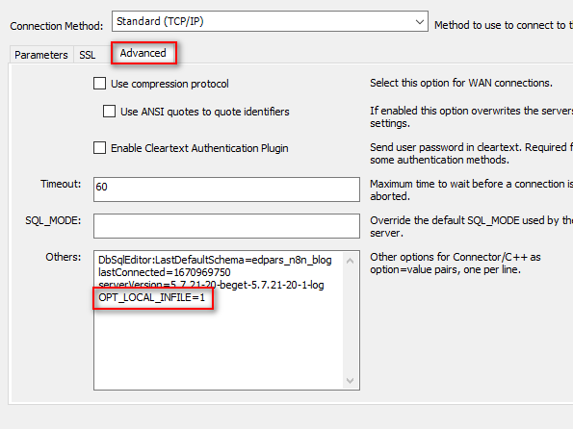Allow import from local files in Workbench 8

Now you can save the new connection by pressing the **OK**button.

**Step 2. Create blank table**

We need to create a table that matches the CSV file that you plan to import. Let’s take a look at one example. This is a simple CSV file that contains seven fields and four records:

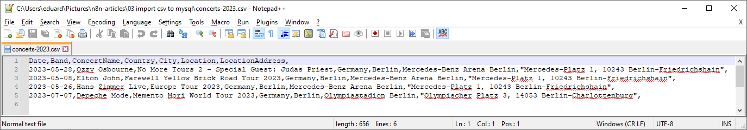Example CSV file

Date,Band,ConcertName,Country,City,Location,LocationAddress,

2023-05-28,Ozzy Osbourne,No More Tours 2 - Special Guest: Judas Priest,Germany,Berlin,Mercedes-Benz Arena Berlin,"Mercedes-Platz 1, 10243 Berlin-Friedrichshain",

2023-05-08,Elton John,Farewell Yellow Brick Road Tour 2023,Germany,Berlin,Mercedes-Benz Arena Berlin,"Mercedes-Platz 1, 10243 Berlin-Friedrichshain",

2023-05-26,Hans Zimmer Live,Europe Tour 2023,Germany,Berlin,Mercedes-Benz Arena Berlin,"Mercedes-Platz 1, 10243 Berlin-Friedrichshain",

2023-07-07,Depeche Mode,Memento Mori World Tour 2023,Germany,Berlin,Olympiastadion Berlin,"Olympischer Platz 3, 14053 Berlin-Charlottenburg",

Content of the example CSV file

After you connect to a new blank database, please select a default Schema. Then right-click on the **Tables** item, select **Create Table** and add the first table as shown on the screenshot.

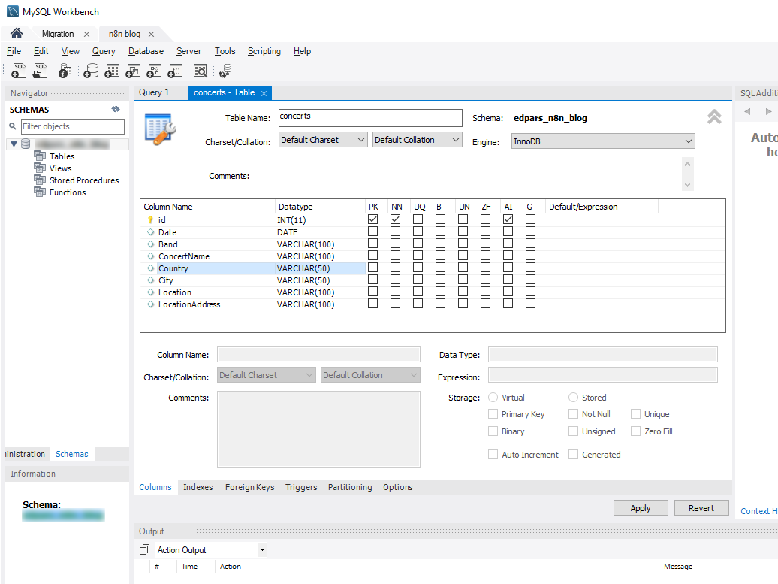Create a new table manually in Workbench

As you can see, MySQL Workbench still creates an SQL statement after you press the **Apply** button.

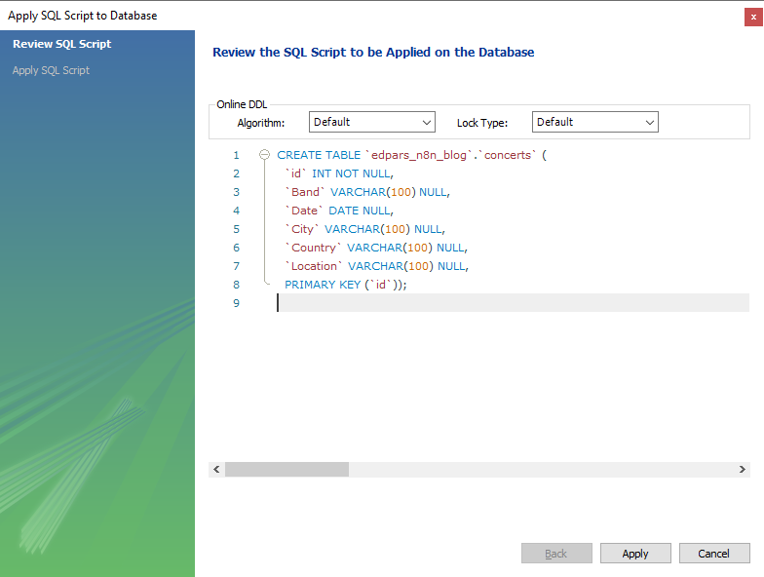SQL commands generated in Workbench

We will discuss these lines in the next section. If you want to change the existing table (i.e. add new variables), right-click **Alter Table** on the concerts table. You will see the same screen again with all variables and their properties.

**Step 3. Import CSV file**

Finally, we are ready to import the CSV into MySQL Workbench. Right-click on the concerts table and pick **Table Data Import Wizard**. Then select your CSV file and follow the wizard.

At one point you'd need to check the mapping of the CSV columns to the MySQL variables. Then click **Next** once again and finally start the import process.

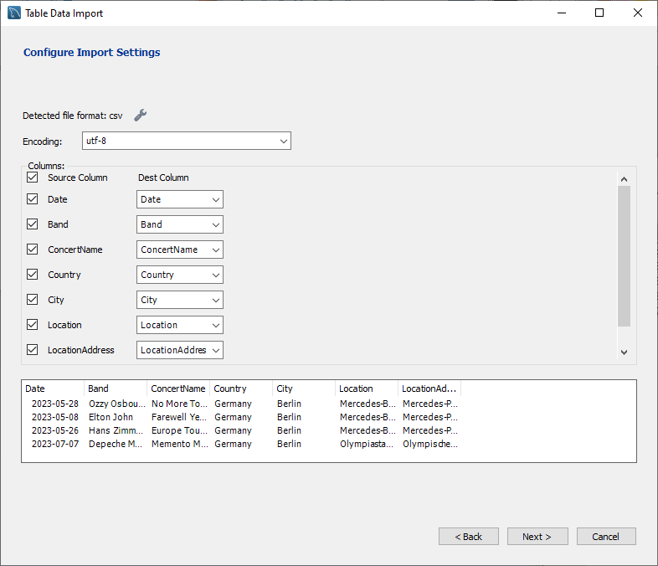Import CSV file in Workbench via a wizard

If everything runs well, you will see a confirmation. Otherwise, a log message with error explanations will appear.

**Step 4. Check the import results**

When you close the Import Wizard window, you´d need to check the table. Right-click on it and pick **Select Rows** this time.

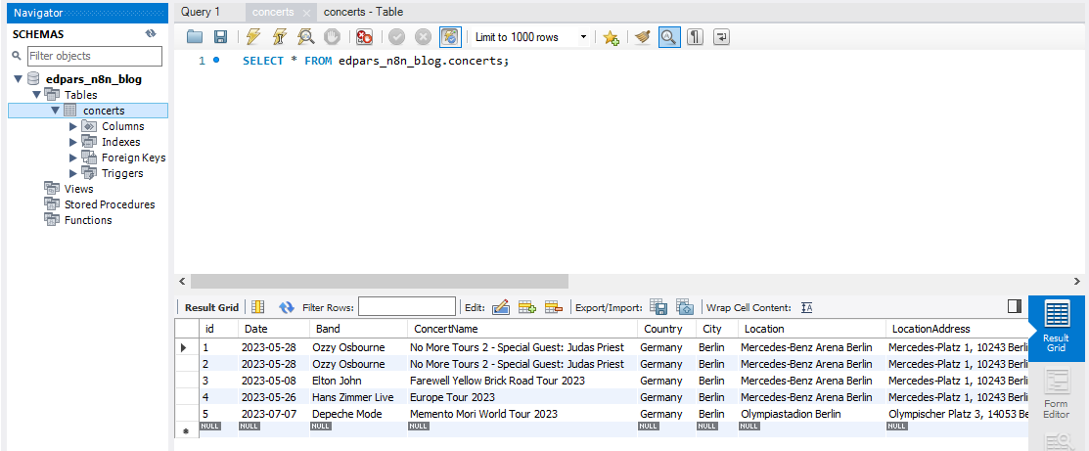CSV file imported successfully

You will see that your table contains data from the CSV file. Great job! It isn't difficult, but a bit tedious.

**Import CSV into MySQL using SQL commands**

In this section, we will show you how to create a new table and import a CSV via MySQL commands in the Workbench program. This way you can remove the repetitive part a bit. But this method requires some knowledge of MySQL syntax. Don't worry, everything will be explained.